**Welcome to Career Services!**

**“74% of recruiters believe hiring will become more competitive in the next 12 months.”**

*–* [*Jobvite Recruiter Nation Report 2018*](https://www.jobvite.com/wp-content/uploads/2018/11/2018-Recruiter-Nation-Study.pdf)

|  |
| --- |
| **KEY TAKEAWAYS:**  – By the end of this Milestone, you will be able to articulate the difference between Employer Ready vs Employer Competitive.  – Review this guide, and [mark complete in BCS](https://www.bootcampspot.com/login).  – [Click here to watch a short video introduction to Career Services](https://youtu.be/Tiuil_uXxG0). |

**WHY WE’RE HERE**

We have talked with thousands of employers, and we know exactly what employers are looking for in top candidates. These conversations have led us to identify that there is a difference between being Employer Ready and Employer Competitive.

* ***Employer Ready*** means that you have the minimum requirements to enter into a typical job application process. Your job search materials are strong and complete, and with some luck, an employer will notice you in a tall stack of applications and decide you are the right fit for the role.
* ***Employer Competitive*** candidates have positioned themselves for success through networking, company research, excellent professional materials, and a strong demonstration of their commitment to ongoing learning. Employer Competitive Candidates are proactively seeking and pursuing the jobs that they want with effective outreach and follow-up strategies.

**We’re here to guide you through the process of becoming Employer Competitive in the job market!**

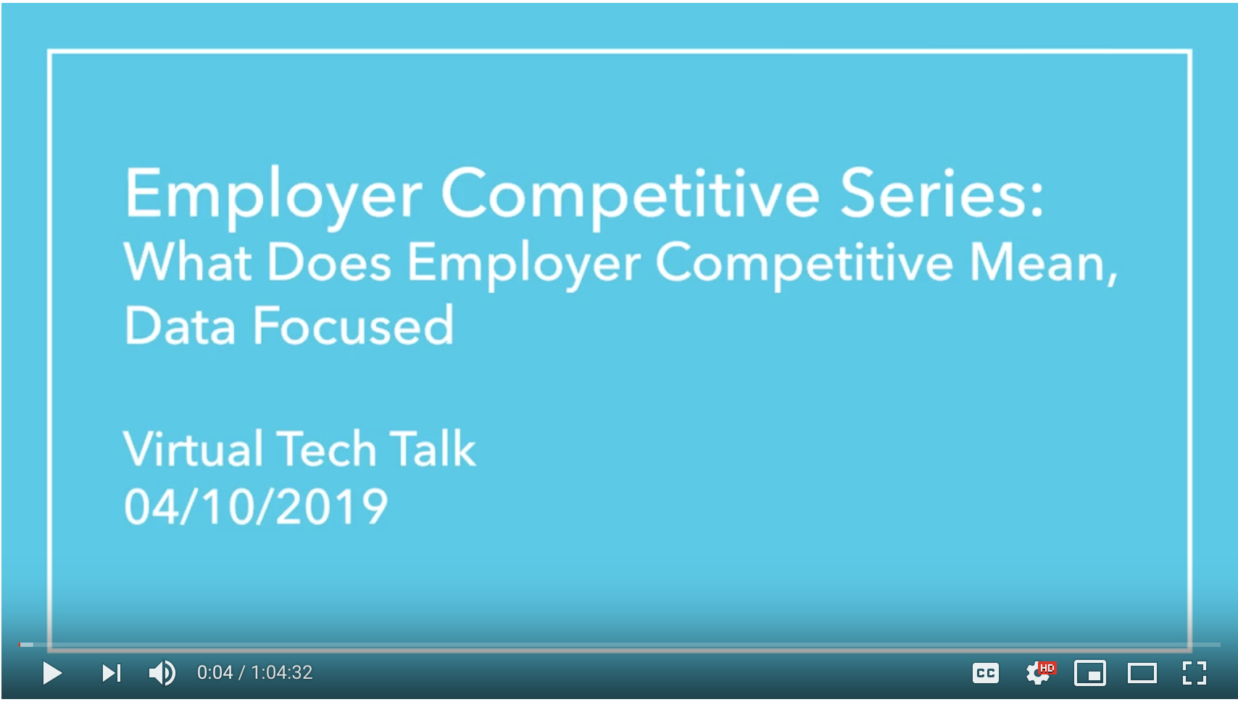

**HOW YOU’RE SUPPORTED**

* **Profile Coach** – Offers unlimited feedback on your professional materials to help you become Employer Competitive.
* **Career Director** – Offers quality coaching, strategies, and resources to help you become Employer Competitive.
* **Career Services Events** – Ongoing behavioral and technical workshops as well as events with industry professionals help you become Employer Competitive. [Click here to watch a 'What Does Employer Competitive Mean' workshop.](https://youtu.be/347Jmjv4OKE)

**WHAT’S AHEAD**

We encourage you to prepare your professional materials before graduation, and through a set of Career Milestones, we offer guidance to help you accomplish that. Although there are suggested submission dates, **these Milestones can be completed at any time and in any order.** See below for an overview.

|  |  |
| --- | --- |
| **– SUBMIT TO PROFILE COACH –** | **– REVIEW ONLY –** |
|  | **MILESTONE 1: Career Services Overview**  Understand Career Services and how we support you in becoming Employer Competitive. |
| **MILESTONE 2: Create Your Brand Statement**  Develop a professional brand statement, and submit your statement to a Profile Coach for feedback. |  |
|  | **MILESTONE 3: Build Your Visibility**  Identify best practices for in-person and online networking, and begin to develop a plan to build your visibility within the field. |
| **MILESTONE 4: Create Your Resume**  Develop an Employer Competitive resume, and submit it to a Profile Coach for feedback. |  |
| **MILESTONE 5: Polish Your Github & LinkedIn**  Update your Github and LinkedIn profiles to meet Employer Competitive standards, and submit links to your Profile Coach for feedback. |  |
|  | **MILESTONE 6: Preparing for a Successful Interview**  Understand how to successfully prepare for the interview process. [Register for behavioral and technical interview workshops on the Career Services events page.](https://careerservicesonlineevents.splashthat.com/) |
| **MILESTONE 7: Employer Ready**  Incorporate previous feedback to your career materials, and re-submit for a final review from a Profile Coach. Once you’re done, you will be Employer Ready! |  |